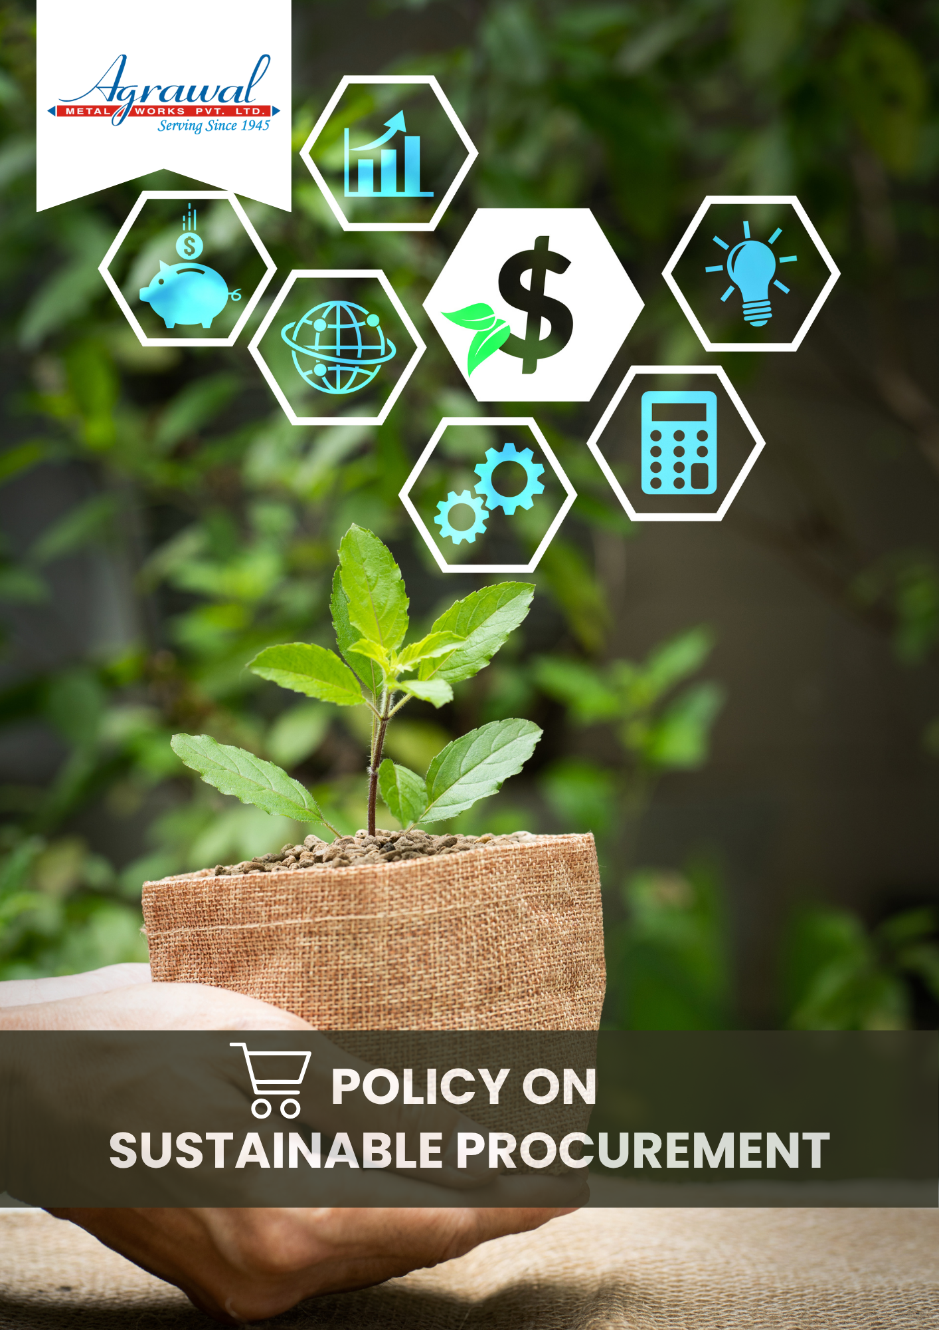

TABLE OF CONTENTS
INTRODUCTION 2
SCOPE 2
POLICY STATEMENT 3
KEY FOCUS AREAS 3
COMMITMENT AND GOALS 3
HARMONIZING SUSTAINABLE PROCUREMENT PRACTICES WITH SUSTAINABLE DEVELOPMENT GOALS 4
RESPONSIBILITIES 5
REPORTING 5
REVIEW MECHANISM 6
REVISION HISTORY 6
EMPLOYEE ACKNOWLEDGEMENT FORM 7

INTRODUCTION

Our Sustainability Procurement Policy underscores Agrawal metal works commitment to integrate environmental, social, and ethical considerations into every facet of procurement practices. By prioritizing transparent and responsible sourcing, we strive not only to minimize our environmental footprint but also to foster a supply chain that promotes social equity and ethical integrity. This policy serves as our commitment to drive sustainable value creation, ensuring that every procurement decision reflects our dedication to a more sustainable future for all stakeholders. This policy aims to promote innovation and collaboration with suppliers to achieve continuous improvement in sustainability performance. Also, to educate and engage our workforce, suppliers, and partners to uphold the highest standards of environmental stewardship and social responsibility.

SCOPE

This Policy is applicable to following sites and all of its employees, workers, sub-contractors and other stakeholders:

Sr. No. | Site | Address
1 | Agrawal Metal Works Pvt. Ltd. | SP-144, RIICO Ind. Area, Phase-1, Bhiwadi – 301019, Maharastra, India
2 | Agrawal Metal Works Pvt. Ltd. | Jhajjar Road, Rewari-123401, Haryana, India
3 | Agrawal Metal Works Pvt. Ltd. | 205, “Arunachal Building” 19, Barakhamba Road –110001, New Delhi, India

POLICY STATEMENT

At Agrawal Metal Works Pvt. Ltd. , we are committed to embedding sustainability into our procurement processes to foster environmental stewardship and social responsibility. Building on the baseline set in FY 2019-20, we strive to collaborate with our suppliers to achieve continuous improvement in sustainability performance, promoting innovation and transparency at every step. By engaging our workforce, suppliers, and partners, we uphold the highest standards of environmental and social responsibility, driving sustainable value creation for all stakeholders.

KEY FOCUS AREAS

- Sustainable Procurement – Environmental Issues: Prioritize suppliers who keeps the inventory on environmental performance and minimize the environmental impact through energy efficiency, pollution control, and responsible resource use and agreed to provide documents of legal compliance.
- Supplier Social Practices: Ensure suppliers uphold fair labor practices, safe working conditions, respect for human rights across all operations, promote the women empowerment and social responsibility in different sectors such as education, health, clean environment etc
- Collaborative Sustainability: Partner with suppliers to co-develop innovative solutions that enhance environmental performance and social value.
- Circular Economy: Prioritize that supplier who believes in the circular economy and focus on the life cycle of the product.
- Local, Inclusive & Diverse Sourcing: Promote procurement from local suppliers, including small-sized, women-owned, and minority-owned businesses, to build community trust and support inclusive economic growth.

COMMITMENT AND GOALS

- To regularly implement a supplier assessment program that evaluates and encourages the adoption of eco-friendly methods, aiming for all suppliers to reduce their carbon footprint.
- Foster partnerships with suppliers who prioritize sustainable practices, ensuring that 80% of our key suppliers are certified by recognized environmental standards (e.g., ISO 14001) by FY 2029-30.
- Reduce overall greenhouse gas emissions from our supply chain by 25% by FY 2029-30.
- By FY 2029–30, ensure that 90% of suppliers are evaluated and documented for their environmental performance, including energy efficiency, pollution control, and responsible resource use.
- To, ensure that all suppliers adhere to fair labor practices by conducting regular audits and providing training on human rights standards
- To develop and implement a supplier diversity program to increase engagement with minority-owned and women-owned businesses.
- To maintain incidents of labor rights violations in our supply chain to zero by FY 2029-30, tracked through annual third-party audits and regular supplier self-assessments.
- By FY 2029–30, ensure 90% of suppliers implement social responsibility initiatives, such as programs for women empowerment, education, health, and clean environment.

HARMONIZING SUSTAINABLE PROCUREMENT PRACTICES WITH SUSTAINABLE DEVELOPMENT GOALS

At Agrawal Metal Works Pvt Ltd, our Sustainable Procurement policy aligns with the following given SDGs.

 |  |  | 
 |  | 

RESPONSIBILITIES
- Procurement Team is responsible for embedding responsible sourcing principles into supplier selection, contract terms, and performance evaluations.
- Sustainability Team oversees supplier performance on environmental, social, and ethical criteria, and facilitates corrective actions and continuous improvement.
- Suppliers are required to comply with Agrawal Metal Works’ sourcing standards, submit necessary disclosures, and fully cooperate during audits and assessments.
- Senior Management provides oversight, ensures adequate resources, and drives enforcement of this policy through periodic reviews and strategic direction.
- All Employees involved in supplier interactions must adhere to this policy and promptly report any violations or concerns through designated reporting channels.

REPORTING
- Supplier Sustainability Compliance: Annual updates on the percentage of key suppliers meeting sustainability criteria, such as certifications and adherence to environmental standards.
- Environmental Impact Metrics: Report on energy efficiency improvements, greenhouse gas emissions reductions, and water conservation efforts achieved through procurement activities.
- Social Responsibility and Labor Practices: Updates on supplier compliance with labor standards, including audits, training programs, and initiatives promoting fair labor practices.
- Innovation and Sustainability Initiatives: Highlights of new sustainability initiatives implemented within procurement, along with their impacts on environmental and social sustainability.
These reporting topics will track and communicate the progress and outcomes of our Sustainable Procurement Policy, ensuring transparency and accountability in our sustainability efforts.

REVIEW MECHANISM

Agrawal Metal Works Pvt. Ltd. implements a robust framework for monitoring and enhancing sustainability in procurement practices. This includes conducting annual performance reviews to evaluate compliance with sustainability targets and progress, alongside regular audits and assessments of suppliers to uphold sustainability criteria. Engaging stakeholders for feedback ensures ongoing refinement of the policy's effectiveness, facilitating continuous improvement initiatives. This review mechanism for our Sustainable Procurement Policy will be reviewed annually by the Procurement Manager, ensuring accountability, transparency, and proactive management of sustainability responsibilities at Agrawal Metal Works.

REVISION HISTORY

Amendment of Revision No. | Effective Date | Details of Amendment of Revision
00 | 01.01.2023 | New Policy Draft
01 | 01.01.2024 | Scope
01 | 01.01.2024 | Commitment and Goals
01 | 01.01.2024 | Review Mechanism
02 | 01.01.2024 | Key Focus Areas
02 | 01.01.2024 | Responsibilities
03 | 01.01.2025 | Key Focus Area

REV. No. 02

LAST REVIEW DATE: 01.01.2025 NEXT REVIEW DATE: 01.01.2026
APPROVED BY:

EMPLOYEE ACKNOWLEDGEMENT FORM
I hereby acknowledge that I have read and understood the Sustainable Procurement Policy of Agrawal Metal Works. I am aware of the company’s commitment to ethical, transparent, and sustainable procurement practices across all raw materials, components, and supplier engagements.
I understand that responsible sourcing includes respecting human rights, avoiding materials linked to conflict or illegal activities, ensuring fair labor conditions throughout the supply chain, and complying with all applicable environmental and social regulations. I recognize that maintaining these standards is a shared responsibility and vital to the integrity and sustainability of our operations.
By signing this document, I confirm my commitment to supporting responsible sourcing practices, reporting any sourcing-related concerns through appropriate channels, and actively participating in training and awareness programs. I affirm my role in helping Agrawal Metal Works build and maintain a supply chain that reflects our core values of ethics, accountability, and social and environmental responsibility.

Employee Name  Employee ID  Date  Signature | :_______________________________  :_______________________________ :________________________________  : _______________________________

